D1.1.2 - Use cases and demonstrator definition – year 2

MOS2S

Media Orchestration from Screen to Screen

**FIRST VERSION**

Edited by: - Seong Yong Lim (ETRI)

Contributions from:

* Omar Niamut (TNO)
* Karim Dahdah (VRT)
* Özer Aydemir, Özgür Devrim Orman (Bor Software), Çiğdem Çavdaroğlu, Emre Aytekin (KoçSistem)
* Seong Yong Lim (ETRI)

Version: 05

Date: 31-03-2018

Delivery date: 31-03-2018

Project key data

ACRONYM and full-length title

|  |  |
| --- | --- |
| **15022** | **MOS2S** |
| Program Call | ITEA 3 Call 2 |
| Full-length Title | Media Orchestration - Sensor to Screen |
| Roadmap Challenge | Urbanisation |

Description

Novel and ubiquitous consumer-priced audiovisual sensors and data in particular, represent an important aspect of the Smart City environment, enabling a variety of applications for citizen information, participation, entertainment, experience, safety and security. Every user becomes a potential source of information, either directly or through social media buzz and its discovery. Audiovisual media provide citizens with Smart City data readily accessible to human senses. With the MOS2S project (Media Orchestration from Sensor to Screen), an international consortium of partners will develop and test audiovisual Smart City technologies and solutions in the context of citizen needs, and embed these solutions within the Smart City Playground.

Project duration & size

|  |  |  |
| --- | --- | --- |
| Size | Effort: 133.67 PY | Costs: 13.9 M€ |
| Time frame | Start: 2016-04-10 | End: 2019-04-30 (37 months) |

Coordinator

|  |  |
| --- | --- |
| Netherlands | TNO |
| Type | Research Institute |
| Contact Person | Gjalt Loots |
| Email Address | gjalt.loots@tno.nl |

Consortium

|  |  |
| --- | --- |
| Belgium | Nokia, IMEC, Kiswe Mobile, VRT* |
| Korea, Republic of | ETRI*, JDI, Samsung |
| Netherlands | Amsterdam ArenA*, Game On, Inmotio Object Tracking BV, Koninklijke KPN NV, TNO |
| Turkey | Bor Software inc.*, DİA Yazilim San. ve Tic. A.Ş., KoçSistem, |

Table of Contents

Project key data 2

ACRONYM and full-length title 2

Description 2

Project duration & size 2

Coordinator 2

Consortium 3

Table of Contents 4

List of Figures 5

Project acronyms 6

1. Introduction 7

2. Use Case Description 8

2.1. Overall scenario description 8

2.2. Experience for fans in the venue 8

2.3. Experience for fans at remote locations 12

3. User Requirements 16

3.1. Requirements for fans at venue 16

3.2. Requirements for fans at remote location 17

4. Demonstrator Definitions 19

4.1. Demonstration at the venue 19

4.2. Demonstration of fan interactions 19

4.3. Demonstration at remote locations in Korea and Turkey 22

4.4. Online Debate Application 23

5. Concluding Remarks 24

List of Figures

Figure 1: wide vision experience in the venue 9

Figure 2: (left) user-generated chats 10

Figure 3: (right) user-generated story feed based on photos and videos 10

Figure 4: watching a live sports game on smartphone in the stadium (left) and on TV and tablet at home (right). 11

Figure 5: Online Debate with remote participants 13

Figure 6: Announcement of a new online debate 13

Figure 7: A Result of the Online Debate 14

Figure 8: Multiple camera capture of a soccer game 15

Figure 9: Real-time preview Figure 10: 3D Reconstructed scene 15

Figure 11: Wide vision demonstrator (Y2). 19

Figure 12: Flemish MOS2S demonstrator (Y2). 20

Figure 13: an interactive TV screen application. 22

Figure 14: an interactive smartphone application. 22

Figure 15: an interactive smartphone application. 23

Project acronyms

|  |  |
| --- | --- |
| 3DoF | 3 degrees of freedom |
| BE | Belgium |
| CPA | Conformance Points A |
| CPB | Conformance Points B |
| DVB | Digital Video Broadcasting |
| IM | Instant Messaging |
| IT | Italy |
| KR | Republic of Korea |
| MOS2S | Media Orchestration Sensor To Screen |
| NL | (The) Netherlands |
| OB | Outside Broadcasting |
| PTZ | Pan-Tilt-Zoom |
| TR | Turkey |
| UHD | Ultra-High Definition |
| VR | Virtual Reality |

1. Introduction

In Deliverable D1.1.2, the MOS2S consortium partners provide use case descriptions and demonstrator definitions for the 2nd year milestone. D1.1.2 is the fourth deliverable from WP1, in which we explore relevant use cases and usage scenarios for MOS2S from the point of platform functionality and valorization potential, so that from these use cases the design requirements can be distilled for the design tasks listed under WP2. Initially the envisaged use cases are Crowd Journalism, Live Events (e.g. sports, music). The process used in WP1 ensures that all stakeholders have a clear view of the usage scenarios for the MOS2S platform and come to a common understanding of the requested functionality, and the requirements should clearly map to individual architectural blocks or interfaces, capturing both what needs to be designed and how this should be tested.

In the first project year, we put focus on live event experiences, and the associated technical work on app development for concept demonstrators. The 1st year use case, as reported on in D1.1.1. saw a separation between professional and user-driven concepts, led by the Dutch and Belgium consortium partners, respectively. In the second project year, the focus shifts to platform integration, for demonstrating the orchestration capabilities of the technical platforms. We expect to see a mix of professional and user-driven concepts, based on the applications developed in the 1st year.

The use case description in D1.1.2 focuses on a Korea-centered live event in a Smart City context, and the associated demonstrator definition is led by the national consortium from Korea. In this deliverable, we further outline this use case description, derive user requirements from it, and present an associated demonstrator definition to showcase the R&D efforts from the MOS2S consortium partners in the 2nd project year.

1. Use Case Description

In the second project year, we focus on platform integration, for demonstrating the orchestration capabilities of the technical platforms. We expect to see a mix of professional and user-driven concepts, based on the applications developed in the 1st year, with real-time and simultaneous demonstration of 1st year app concepts, orchestrating sensors data over a diverse et of screens. We define multiple usage scenarios around a live sport game in a smart venue, that help steer out technology developments and guide our platform integration work.

* 1. Overall scenario description
* Centered around UWV as an innovative video format for live events, driven by Korean partners.
* Demonstrator will include the world’s first intercontinental UWV broadcast between Korea and NL.
* Setting and background is a live sports events in the Amsterdam ArenA.
* In the venue, supported by a moderator, a dedicated analyst uses the online debating system and the coaching application to lead an online debate before and after the game; and to perform a real-time analysis during the game.
* The event is broadcasted to several locations, including in-venue;
  + in Turkey, viewers can watch the game in a pub and up to 2 viewers can join the online debate;
  + In Korea, viewers can watch the UWV content in controlled space and up to 2 viewers can watch in 360/VR;
  + home viewers in NL can watch the game on their TV, with additional game and player data;
  + fans in the venue consume content though a mobile app; live game footage, analyst content and relevant social media;
  + fans in the venue can see UWV content and game / fan moments on the public displays in the venue.
  1. Experience for fans in the venue

**Public screens: wide vision experience in the venue**

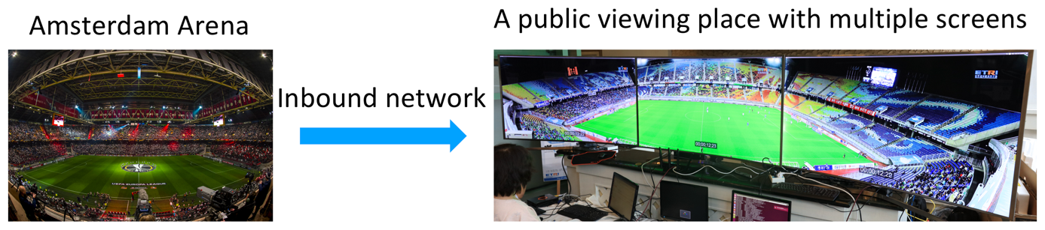

Figure 1: wide vision experience in the venue

Today, the professional football team of *Kees* and *Matteo* will play in Amsterdam Arena. During the game, Kees and Matteo want to drink some strong ones so they visit a cafeteria in the stadium. They don’t need to lose any minutes of the game since the cafeteria has a set of multiple screens which is showing the stadium at wide field of views (**UC PS.v.1**)

However, the wide field of view screens can show only from one-side of the stadium, Kees is wondering the views from the other side. He put a HMD and he can see another view of the stadium (**UC PS.v.2**).

On the other hand, the main director of a local broadcasting service, Cameron, is in charge of broadcasting within the Amsterdam Arena. At a switching room, he sees the live feeds from a set of multiple cameras which are placed in a rig (**UC PS.v.3)** and another feed from the NL broadcasting service. When he needs to switch one from another, he can select a set of live feeds (**UC PS.v.4**).

**Public screens: Wall of Moments**

During the event in the Amsterdam ArenA building, several screens have been installed. Those screens are connected to the MOS2S platform to deliver a constant stream of user contributed media assets (**UC PS.v.5**). A couple of screens are accompanied by iBeacons to deliver a more interactive experience to the people passing the screens. Screens update their content to be more relevant to the user that’s in close range of the screen (**UC PS.v.6**). During the soccer match, the editorial team of the organiser is asking people to send in several types of content to be used on the screens and in the stories stream in the mobile app. At the Amsterdam ArenA, a mini studio has been set up with a camera and an interviewer. People using the app can sit in the studio next to the reporter. She asks the person sitting next to her questions about the soccer match. Meanwhile the interview is recorded on video (**UC PS.v.7**). After the interview the editorial team clips the video. The clipping system automatically adds a nice video bumper to the clipped video, making it a more professional video (**UC PS.v.8**).

**Mobile screens: interactive social viewing with user-generated contents in the venue**

At a sports, music or other event people want to have the best experience possible. Nowadays people post photos on social media using their personal account to show their friends and family the atmosphere at the event. Media content generated by the audience can enhance the global event experience for people at home as well as people at the event or people who are on their way to the event. Event organisers can build upon the shared media assets and create stories of experiences at the event. Before the event the event organiser can interact with people (**UC MS.vp.1**) that will go to the event, creating the excitement before the start of the event. At the same time, it makes it possible for the event organiser to have as many people as possible to download and use the mobile app, so that the experience during the event can be as unique as possible to the people at the event. The mobile app will be the centrepiece of the personalised event experience. After the event, the event organiser can interact again with the audience and give them an after experience with highlights or interesting stories created during the event. The different aspects of the scenario are discussed in detail below.

*Before the event*

Tomorrow, the national football teams of *Kees* and *Matteo* will play again against each other in Amsterdam Arena. *Kees* and *Matteo* download the event app which have been mentioned in an e-mail sent by the event’s organiser. In the app *Kees* and *Matteo* select which soccer team they want to follow (**UC MS.vu.1**). After this selection they are greated with a question (**UC MS.vp.2**) to put a friendly bet on the outcome of the game. The app has a twofold interface. It has a chat-based UI where people can send in text, photos and videos (**UC MS.vu.2**). In that same chat interface, the event organiser is able to interact with the end user, sending messages back to the user or broadcast a question to a selection of users (**UC MS.vp.3**). Some messages from users will be handled by an automated system; a chatbot will try to answer as much questions the system receives to minimize the editorial impact to the event organiser (**UC MS.vp.4**).

 

Figure 2: (left) user-generated chats

Figure 3: (right) user-generated story feed based on photos and videos

The app also features a stories feed (**UC MS.vp.5**). This is a way for the event organiser to create compelling stories based on photos and videos received by the audience. But it can also embed interesting posts found on social media platforms and clips generated by the GameOn analysis system.

*After the event*

The day after the soccer match Kees and Matteo receive their video with the interview they have made at the event (**UC MS.vu.3**). Through the mobile app they can share that video on social media (**UC MS.vu.4**). The event organiser is happy to see that lots of people have shared their experience on Facebook and Twitter. The editorial team creates a new video based on all gathered user generated content to create a nice resume of the event and sends it through the app to the audience.

**Mobile screens: augmented viewing with auxiliary data in the venue**

This usage scenario details the scenario for displaying and interacting with high quality live content on primary home TV screen and secondary companion screens, e.g. smartphones or tablets. The principal focus is on efficient distribution of high quality multimedia streams, advanced rendering of navigable video and interactive data overlays. A concept called “de thuis analist”, or amateur analyst, enhances both in-venue and in-home fan experiences with a dedicated data-integrated interactive video application, featuring navigable 360/UHD video and accurate player and game data and statistics (see **Error! Reference source not found.**). The amateur analyst application bridges the gap between professional coaches and amateur enthusiasts. As this usage scenario involves delivery to residential end-points, it is reasonable to assume that the consumer has a fixed and therefore relatively stable network connection to the content producer/distributor, and that this connection is sufficiently capacitated in terms of network bandwidth to guarantee the streaming of the audiovisual content in maximal quality. There is no pre/post-game experience, the main differentiation is made between viewers in the stadium, and viewers at home.

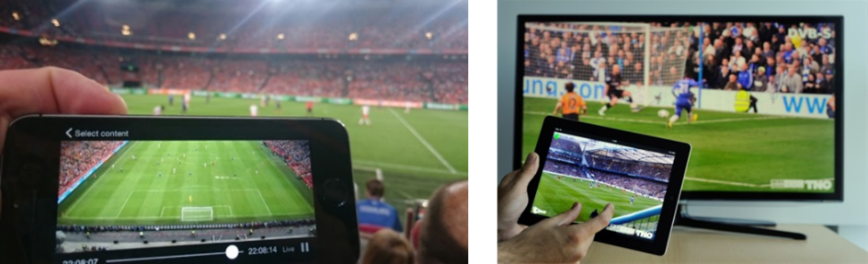

Figure 4: watching a live sports game on smartphone in the stadium (left) and on TV and tablet at home (right).

Today, the national football teams of *Kees* and *Matteo* will play against each other in Amsterdam Arena. Kees will follow the game in the Amsterdam Arena, since he bought tickets to the event a few weeks ago. He brings his smartphone (**UC MS.vu.5**), to watch highlights and replays in the stadium during the game. He also takes his tablet so he can see game statistics and real-time player data (**UC MS.vu.6**), and interact with the video on the tablet (**UC MS.vu.7**).

* 1. Experience for fans at remote locations

**Wide viewing experience at a remote site**

The game in the Amsterdam Arena is broadcasted live or delayed in Korea. Youngmi is watching the game through multiple screens in a cafe with her friends. Because of time difference, she had to wake up too early to see the game in real-time. On the other hand, she could see the recorded game which was held yesterday. Since the multiple screens convers most of the stadium, she can see the both of goalies at a same time (**UC RE.w.1**). She and her friends discuss the defence strategy and the missing regions during the game without any dependency on the ball position. Moreover, Youngmi can see the game though a HMD (**UC RE.w.2**).

**Online debate during the game**

All users join in the system as a guest. These users can only see “Public Debates”. Guest Users can join into debates as a Guest account which assigned to them. In addition to, they can chat with other users, vote to debaters and respond to surveys which are published by Moderator in debate.

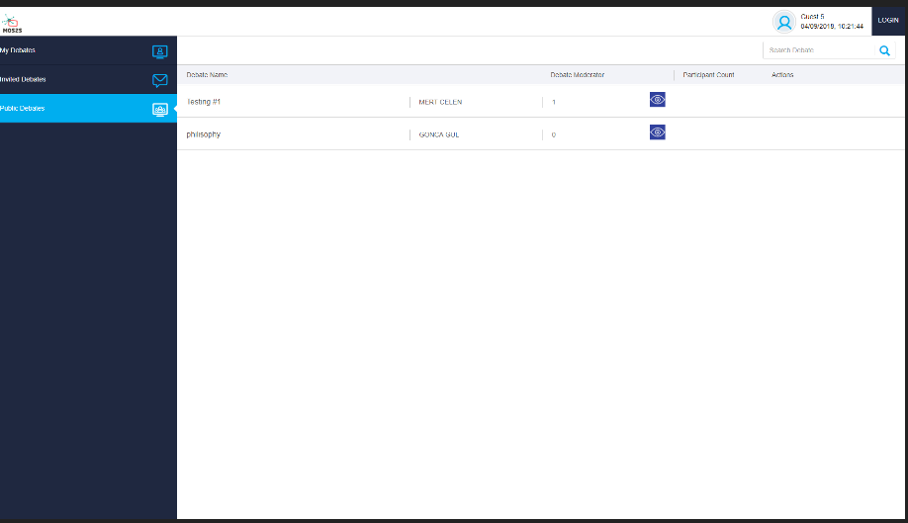

Figure 1: Main Screen

The guest clicks the “Login” button to log in to the system.

i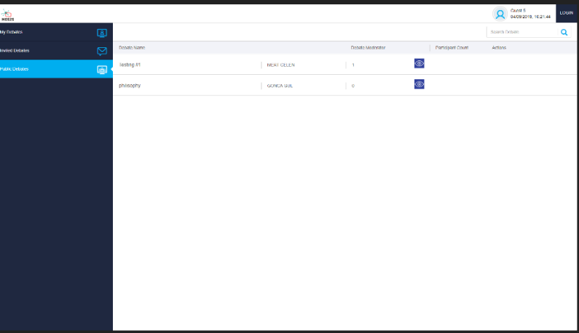

Figure 2: Login Screen

In this page if guest has an account, fill in the E-mail / Username and Password then login the system, else guest can create new account by click “Create New Account” button.

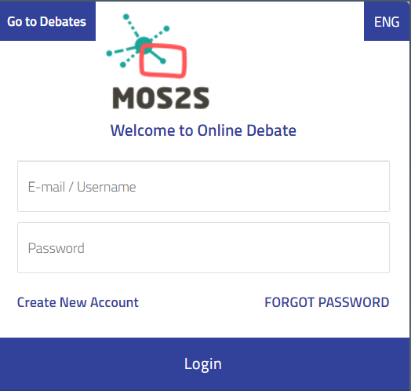

Figure 3- Login Page

### Create new account

The user's name, surname, username, e-mail address and password are entered and the user register to the system by clicking on the "Create New Account" button.

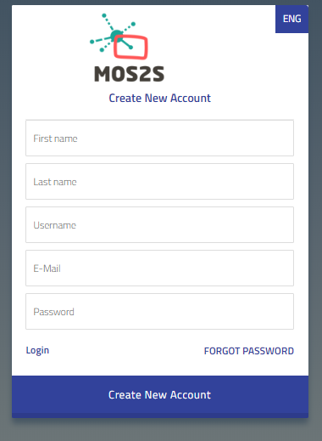

Figure 4- Create New Account Page

This image is the main page of Online Debate System, in the left side of the page “My Debates, Invited Debates, Public Debates” menus are located in Image 5.

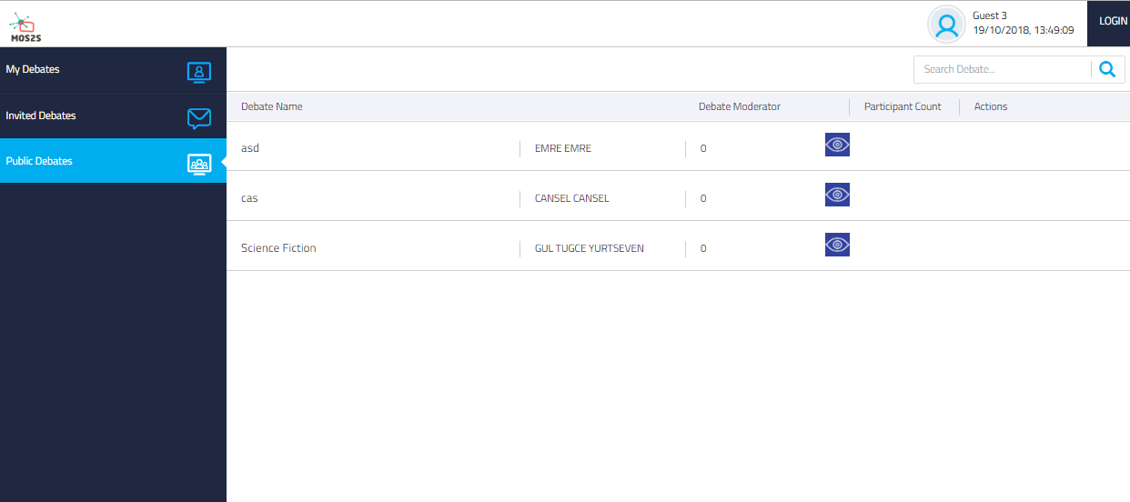

Figure 5- Create New Account Page

* **Public Debates:** In the public debates page all published debates are displayed and if the guest wants, guest can click the button in the Transactions tab to view the debate.



Figure 6: Public Debates

* **Invited Debates:** Like the public debates page, users can see list of debates that he or she is invited as a debater by debate owner ( moderator).

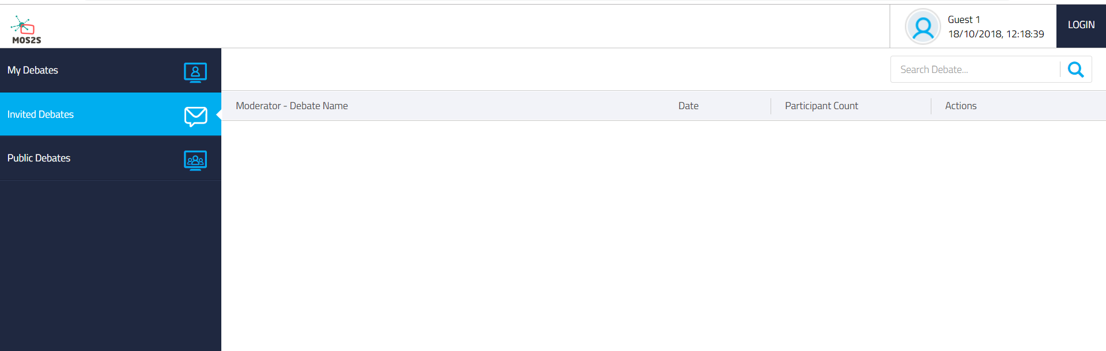

Figure 7: Invited Debates

In this screen user can attend one of the debates as debater by clicking the “Join to Debate” button in Image 6.

* **My Debates:** Logged in user can create new debate in this page and display all debates which are created by himself. If any debates have been created, these can be managed in this page. “Join to Debate” and “Delete Debate” operations can be realized via the options in the transactions column, also can filter debates by using the search box located on the right corner, see Image 7.

In order to create a new debate new form is opened after clicking the “Create Debate” button.

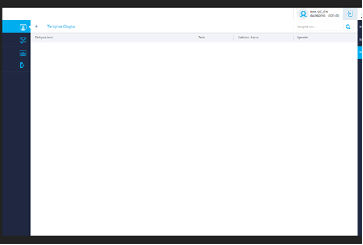

Image 8: Create New Debate

Debate name is written and debaters are selected from the Online users list for inviting to debate, see Image 8.

Then, “Start Debate” button is clicked and invitation is sent to debaters, see Image 9.

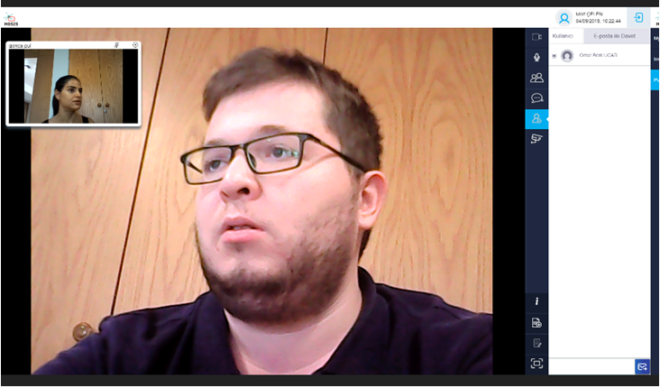

Image 9: Debate Invitation

If user confirms the invitation, attends to debate as debater, see Image 9.

* **Add Stream:** User can add streaming media to share with other users during debate.
  + **My Resources Tab:** List of user’s resources, see Image 10.

Image 10: Add Streaming Media-List Of User’s Resources

* + **Add Youtube Url Tab:** User can add Youtube Url to system, see Image 11. The name and description of this Youtube video is taken by system automatically.

Image 11: Add Youtube Url

* + **Add Web Url Tab :** User can add website url to system. User fill in title, description and url then click add button, see Image 12.

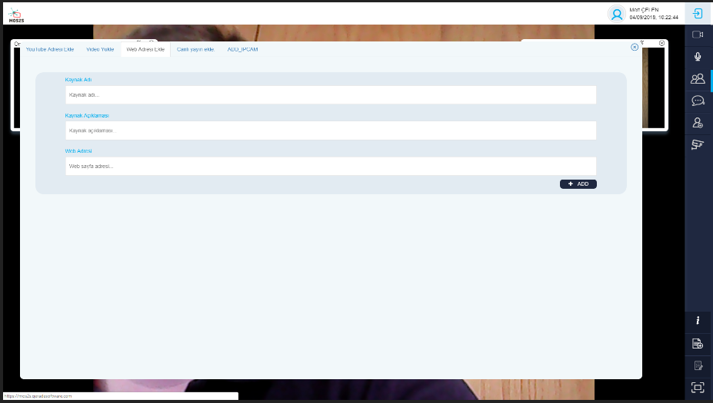

Image 12: Web Url

* + **Add HLS Tab :** User can add live stream formatted as HLS to system. User fill in title, description and url then click add button, see Image 12.

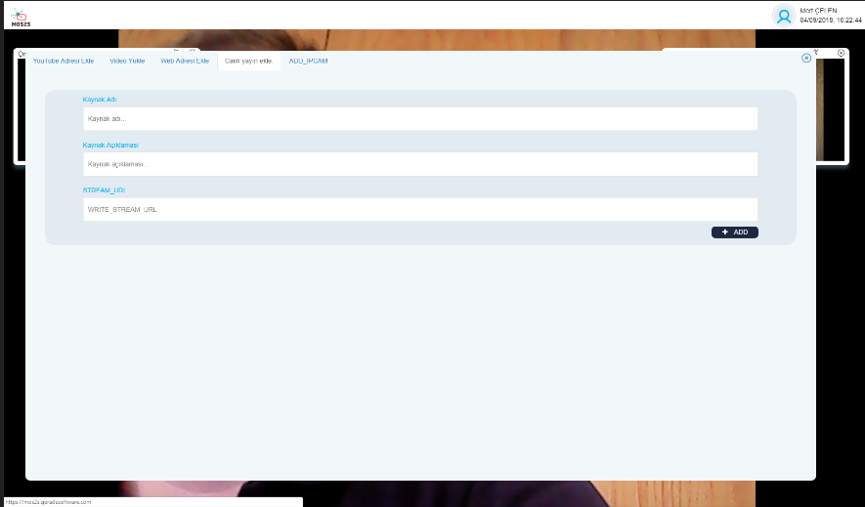

Image 13 Add HLS

* **Add IP CAM:** User can add IP cam on debated. User fills in title, description and url then clicks add button displayed on Figure 14

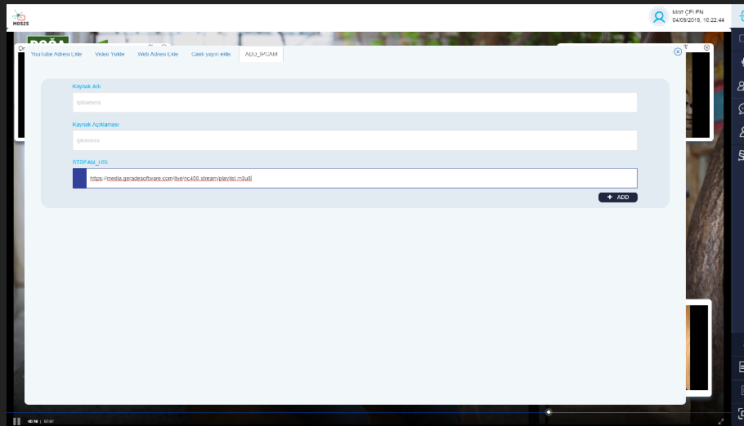

Image 14: Add IPcam

**ONLINE DEBATE**

* **Participant List:** Debaters who joined to current debate are displayed in this panel, see Image 13.

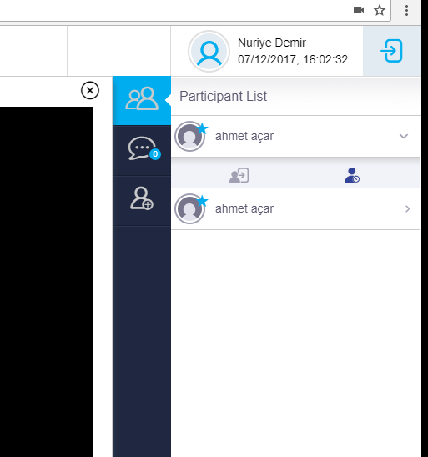

Image 13: Participant List

* + **Kick User From Debate:** Moderator can kick the users from debate, see Image 14.

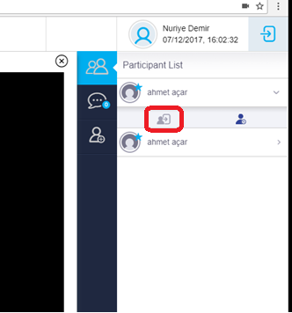

Image 14: Kick User

* + **Ban User From Debate:** Moderator can ban the users from debate, see Image 15.

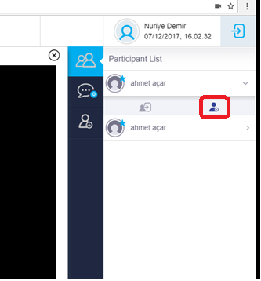

Image 15: Ban User

* **Chat:** All participants can chat about the debate, see Image 16.

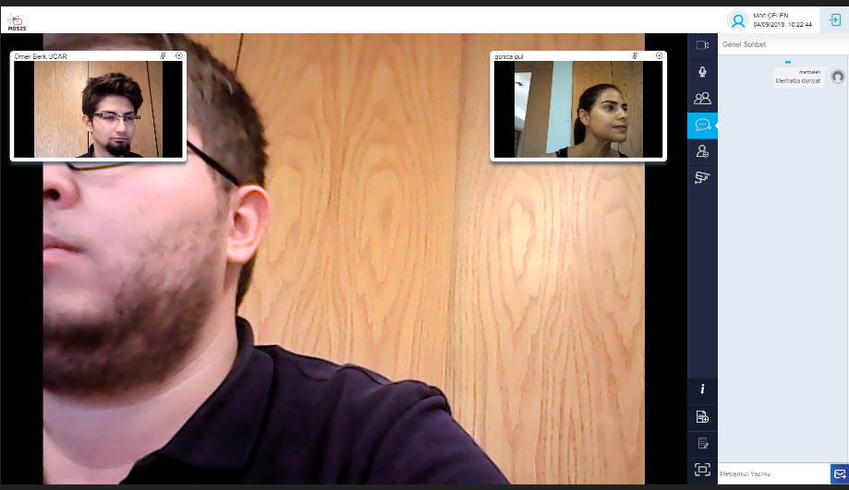

Image 16: General Chat

* **Invite participants:** Moderator can invite another debaters (up to four people), when the Invite Debate button is clicked, tab menu screen is opened.
* **Users:** In the first tab menu “User” users who have been enrolled in system and being online are listed, moderator can select people from the list and invite him/her by clicking “Send” button is located at the bottom of the screen, see Image 17.

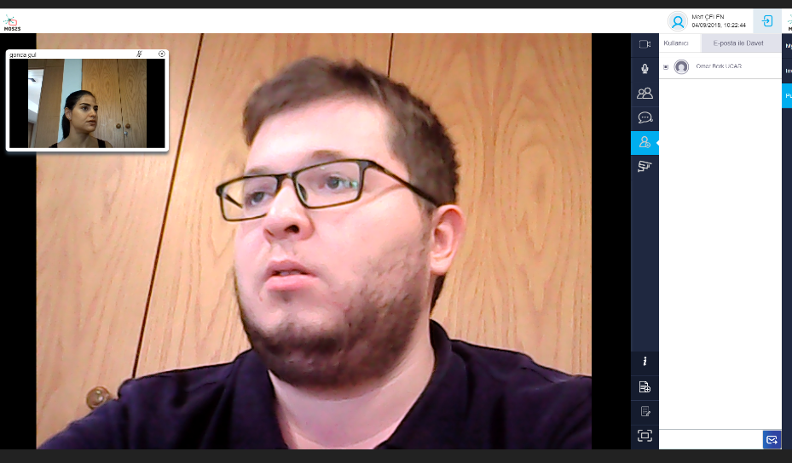

Image 17: Invite participant via user name

* **Via E-Mail:** In addition to this, if the moderator wants to invite a debater who has not enrolled in the system he/she can invite the debater via e-mail from the tab menu, see Image 18.

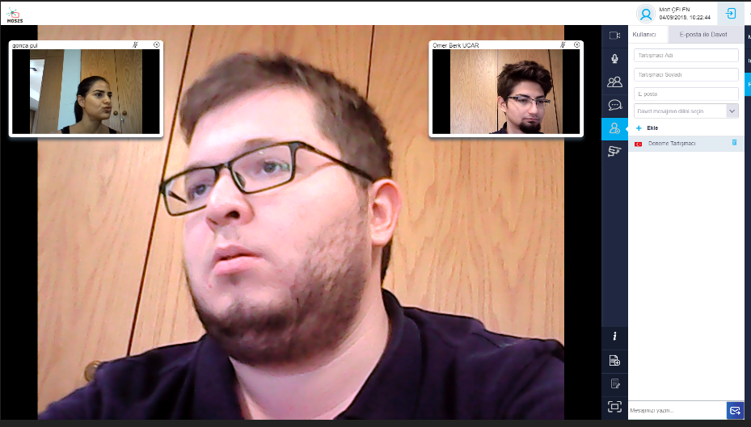

Image 18: Invite participant via email

Moderator can invite more than one debater at the same time. For this operation moderator should enter debater’s information and click “Add” button, people are listed, finally by clicking the “Invite” button at the end of the screen, then an invitation mail is sent to people, see Image 19.

Image 19: Adding more participants at once via email

Moderator can perform “Publish” and “Delete” operations for streams. If he clicks “Publish” button streaming media is shared with other participants displayed below

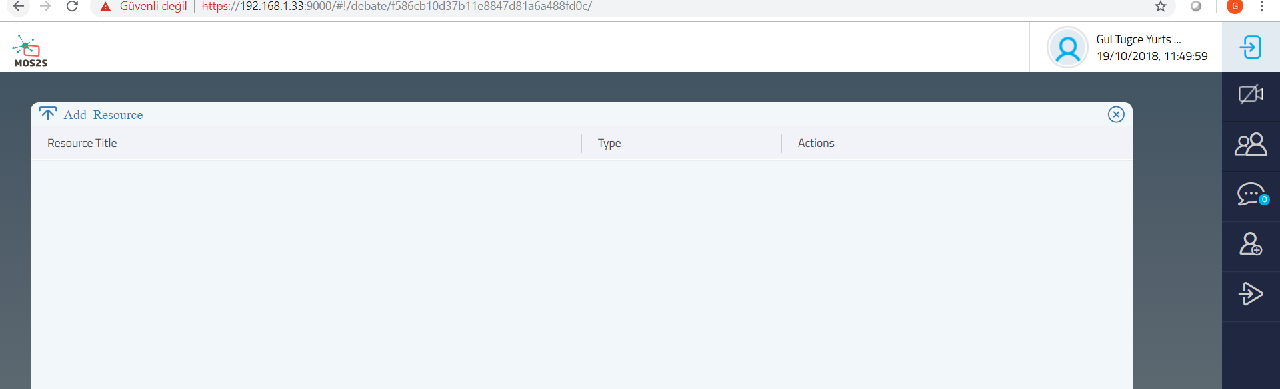

Image 20: The screen to add stream and videos to be published.

Also moderator can add new stream or website url by click "Add Resource" button during the debate, see Image 21

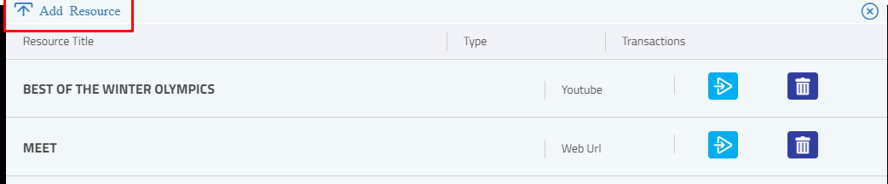

Image 21: Add Resource

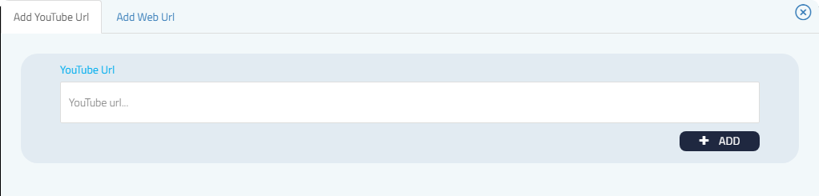

Image 22: Add Youtube Url

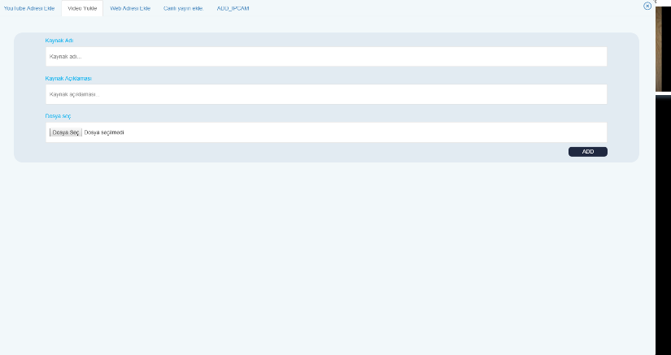

Image 23: Add Video Screen

When moderator publish stream, this stream is published with all the debater and viewer. The control of stream such as play,pause,stop publishing,seek is made by moderator. Debaters and viewers can change volume of the stream only.



Image 23: Moderator Screen

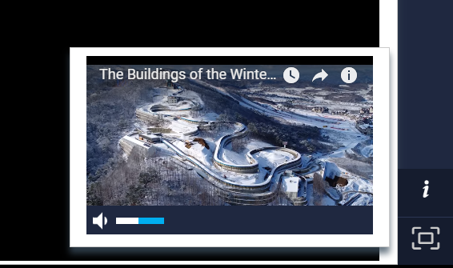

Image 24 Debater and Viewer Screen

* **Debate Topics:** Moderator can add debate topics, these are added for getting statistics.

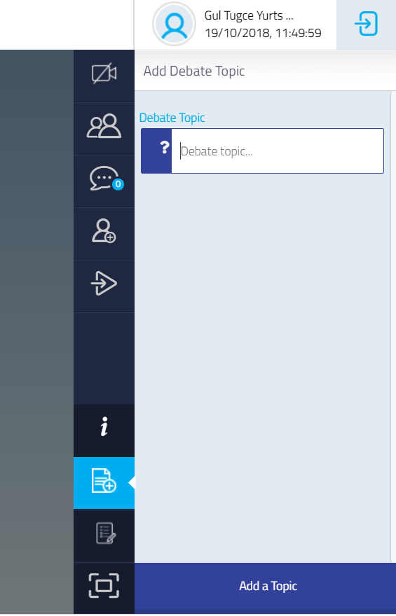

Image 25: Adding Debate Topic

Added topics are listed in the screen, see Image 26.

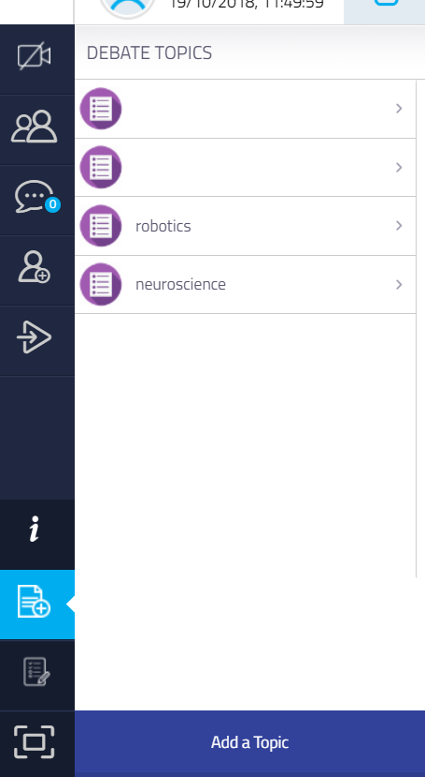

Image 26: Added Debate Topics

During debate, participants can evaluate the topics by clicking “Like” - “Dislike” and “Agree”- ”Disagree” buttons on their screens, see Image 27.

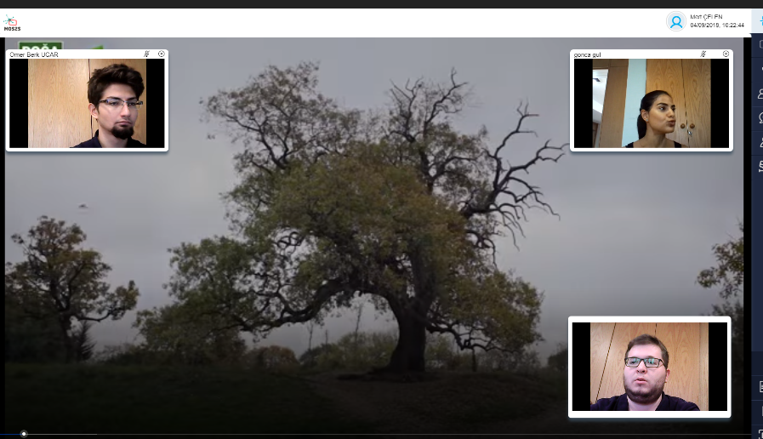

Image 27: Evaluating debate topics

Moderator can view the result of the debate topics (*see Image 29*) from his screen by clicking the listed topics, Image 28.

|  |  |  |
| --- | --- | --- |
| Image 28: Debate topic transactions |  | Image 29: Statistics about debate topic |

* **Survey:** Moderator can create, edit and publish a survey about debate, and also can display the published, unpublished and completed surveys, see Image 30.

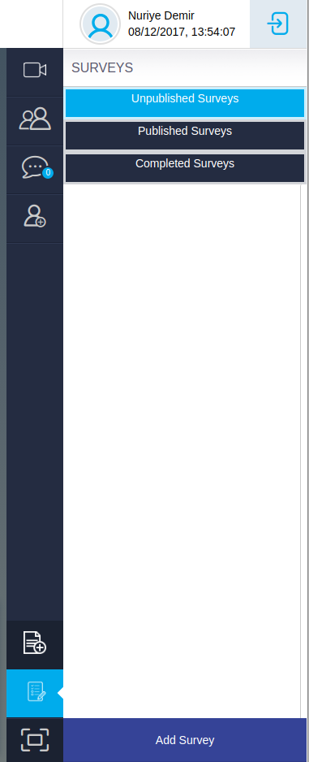

Image 30: Surveys

* **Add Survey:** In order to create a new survey “Add Survey” button is clicked and moderator is directed to new screen see Image 31

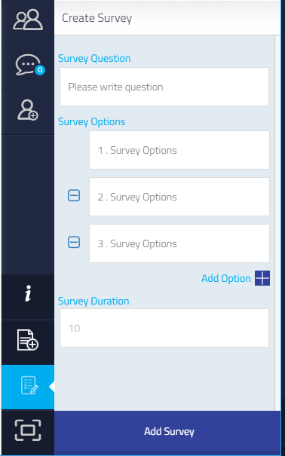

Image 31: Adding New Survey

Survey Question, survey option and survey time text boxes are filled. If user wants to add more option “Add Option” button is clicked and new options are added. Operation is completed after “Add Survey” button is clicked, see Image 32.

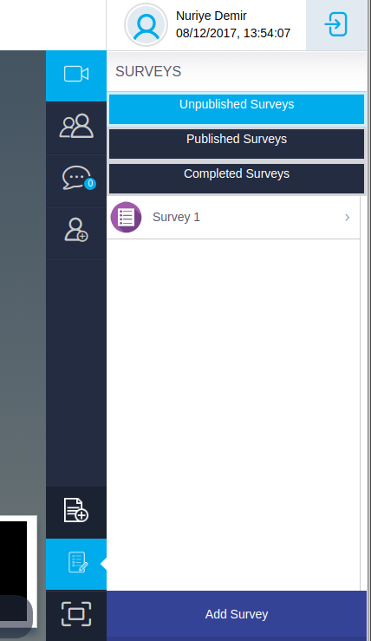

Image 32:Display screen lists of surveys

* Publish Survey

Moderator can publish survey to viewer by click publish button, see Image 33

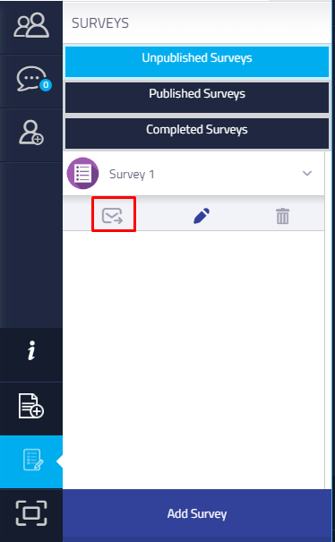

Image 33 Publish Survey

When moderator publish survey, this survey will be displayed on viewer’s screen, See Image 34

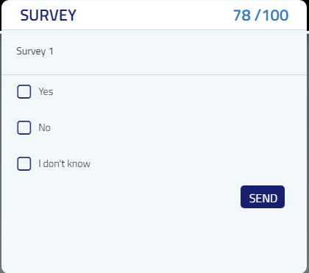

Image 34 Survey on Viewer’s Screen

Saved survey is listed, see Image 32. Moderator can display the survey results, see Image 33.

|  |  |  |
| --- | --- | --- |
| Image 34: The screen displaying Survey related information |  | Image 35: Adding New Survey |
|  |  |  |

* **Open/Close Camera**

Each debater can close his/her own camera by clicking the cross button on the streaming box, see Image 36

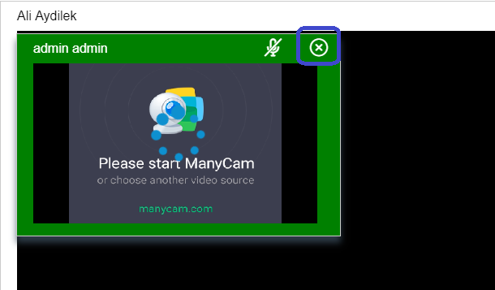

Image 36

Each debater can open his own camera by clicking the camera button on the menu, see Image 37.

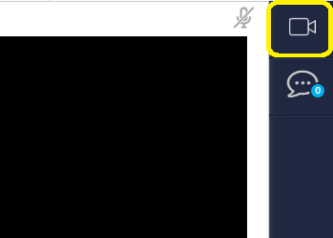

Image 37

Also the moderator can close or open each debater's camera.

The moderator sends a request to the debater to open debater's camera, see Image 38.

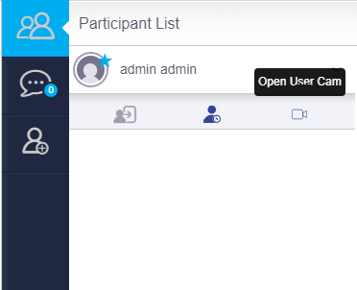

Image 38

When moderator send an open camera request, the debater see the notification in the lower right of the screen, See Image 39. If the debater agrees to open the camera, debater clicks the "OK" button. After that the debater’s camera is opened.

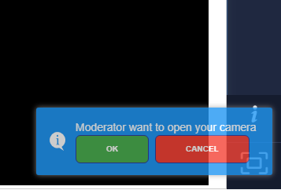

Image 39

* **Full Screen:** Last button is clicked to watch the debate in full screen format.

1. User Requirements

This chapter describes user requirements, derived from the usage scenarios in chapter 2. All requirements in the venue, home and remote are captured.

* 1. Requirements for fans at venue

|  |
| --- |
| UC PS.v.x: Public Screen use case requirement at the venue- number x  UC MS.vp.x: Mobile Screen use case requirement for Professional users - number x  UC MS.vu.x: Mobile Screen use case requirement for generic users - number x |

*Overall*

* **UC ALL**.g.1 – Content from the social media analysis, video clipping service and soccer analyst system need to be able to interact with the user interaction platform
  + **UC PS**.g.1-a – The interaction platform need to have an API available

*In the venue*

* **UC PS.v.1 –** when at the venue, users can watch the game via a set of multiple screens at wide field of views.
* **UC PS.v.2 –** when at the venue, users can watch the game via a HMD at wide field of views.
* **UC PS.v.3 –** when at the venue, a producer can watch the live feeds from a set of multiple cameras.
* **UC PS.v.4 –** when at the venue, a producer can switch one from another.

*During event*

* **UC PS.v.5** – a host is able to push media content to digital screens
* **UC PS.v.6** – a screen can be made interactive through ibeacons
* **UC PS.v.7** – a host can video capture an interview with a user
* **UC PS.v.8** – a host can create clips from the recorded video

*Pre-event*

* **UC MS.vp.1** - an editor can interact with people via a chat-based method and can send text, photos, videos and polls
* **UC MS.vp.2** -a host is able to send a questionnaire automatically after a new user activates the mobile app
* **UC MS.vp.3** -a host can send content to a segment of users
* **UC MS.vp.4** -a chat bot can automatically answer a selected set of questions
* **UC MS.vp.5** -a host is able to manage a feed of stories
* **UC MS.vu.1** – a user is able to select a soccer team
* **UC MS.vu.2** – a user can send in text, photos and videos

*After the event*

* **UC MS.vu.3** – the system can send the branded video clip to the corresponding user
* **UC MS.vu.4** – a user can share the interview video on social media platforms
* **UC MS.vu.5 –** when in the stadium, users can use their mobile devices to see highlight and replay videos.
* **UC MS.vu.6 –** users can use their tablet to see game statistics and real-time player data.
* **UC MS.vu.7 –** users can use their tablet to interact with the video.
  1. Requirements for fans at remote location

|  |
| --- |
| UC RE.w.x: Remote use case requirement for wide vision exprience- number x  UC RE.ou.x: Remote use case requirement for generic users - number x  UC RE.op.x: Remote use case requirement for professional users - number x  UC RE.xp.x: 3D reconstruction use case requirement - number x |

*At the remote location*

* **UC RE.w.1 –** when at the remote location, users can watch the game via a set of multiple screens at wide field of views.
* **UC RE.w.2 –** when at the remote location, users can watch the game via a HMD at wide field of views.

*Pre-event:*

* **UC RE.ou.1 -** A fan can start a debate on Online Debate site
* **UC RE.ou.2 -** Open the application on his Android tablet
* **UC RE.ou.3-** Clicks to start a new debate
* **UC RE.ou.4-** Set the category and the topic
* **UC RE.ou.5 -** Put screenshot of the position as the debate background
* **UC RE.op.1-** An invitation is sent to moderators
* **UC RE.op.2-** After one of available moderators accepted invitation, debate is indicated as in “waiting for the participants” state
* **UC RE.ou.6-** Other participants can join to the debate on their mobile phones or tablets by selecting the debate
* **UC RE.ou.7 -** Start waiting for the beginning of the debate.
* **UC RE.op.3 -** After three participants are joined to debate, Moderator announces debate will start in 30 seconds

*During event*

* **UC RE.op.4 -** Offending any party in the debate is penalized and the participant who offends is dismissed by moderator
* **UC RE.ou.8 -** Each participant can watch others on the same screen simultaneously
* **UC RE.ou.9 -** Participants can send text messages on the IM tab of application
* **UC RE.ou.10 -** Audience can take a look Online Debate Site on a web browser
* **UC RE.ou.11 -** Audience can search if there is any active debate about any game
* **UC RE.ou.12 -** Audience can start to watch debate online by clicking debate topic link
* **UC RE.ou.13 –** Audience can click “Like” or “Dislike” icon located on the debater’s frame according to their thoughts

*After event*

* **UC RE.ou.14 –** Audience can view details by clicking the link of that debate
* **UC RE.ou.15 –** Audience has a chance to watch debate again and to explain her/his thought
* **UC RE.ou.16 –** Audience has chance to “Like” or “Dislike” comments of others

*3D Reconstruction*

* **UC RE.xp.1** - An organizator can initiate the 3D reconstruction process.
* **UC RE.xp.2** - Logins to the system with organizator credentials.
* **UC RE.xp.3** - Selects the current or the older options
* **UC RE.xp.4** - Selects an old competition from the list.
* **UC RE.xp.5** - Clicks to the initiate button.
* **UC RE.xp.6** - A preview will be displayed.
* **UC RE.xp.7** - The video streams will be saved.
* **UC RE.xp.8** - The user logins to the system with user credentials.
* **UC RE.xp.9** - Watches the content.
* **UC RE.xp.10 –** Whole content can be accessible from the same web site through the “History” tab
* **UC RE.xp.11 –** All previous debates are listed in the “History” page

*Other requirements:*

* System informs participants with a pop-up text
* Current and last debates are listed in Online Debate site on web
* Debate consists of 2 turns
* Each participant has 2 minutes to explain her/his thoughts

1. Demonstrator Definitions

We aim to organize our second public demonstration of the MOS2S innovations and technologies at an event on September. We plan to show our first integration effort through demonstrations of primary parts of the MOS2S system and applications, with a focus on the orchestration capabilities of the MOS2S platform.

The year 2 demonstrator (Q3 2018) is part of T3.3, Demonstrator Design. In this task, a first demonstrator based on integrated platforms and technologies will be performed. A live event, e.g. sports game or concert, will be selected as context for the demonstration. First feedback from stakeholders will be retrieved, and a limited validation of technologies will be performed, to steer the next phase of development.

* 1. Demonstration at the venue

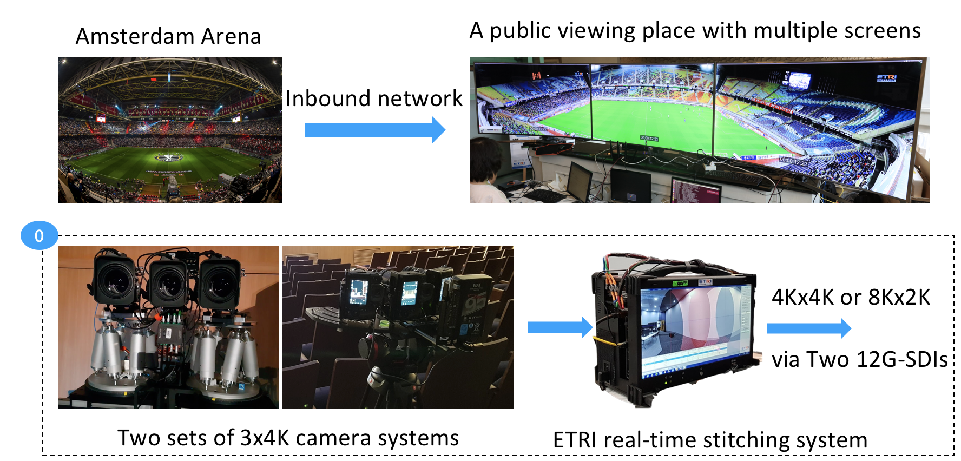

Figure 11: Wide vision demonstrator (Y2).

In this demonstration, the MOS2S partners will focus on the immersive experience with wide vision screens and interactive mobile applications. For that purpose, professional camera systems will support the demo, most notably

* A multi-camera capture system and wide-view generation system from ETRI and Samsung
* A mobile applications from GameOn and VRT.
  1. Demonstration of fan interactions

As part of the overall MOS2S demonstrator, the Flemish demonstrator will focus on extension (pre- and post-event) and enhancement of the user experience, based on automated video capturing co-creation (Kiswe and VRT) and editor-driven creation of stories (MOS2S Editor Dashboard) with the fan in and around the football stadium and via social media posts (Nokia and VRT) with the viewer at home. The main concepts of the Flemish demonstrator are depicted in Figure 15 below.



Figure 12: Flemish MOS2S demonstrator (Y2).

* a wide variety of input streams (professional and user gen content, social media feeds, game analysis data) are processed and orchestrated into a coherent set of different output fan experiences:
  + **Wall Of Moments** on a set of public displays in and around the stadium; each display can carry specific content.
  + Wall of Moments Mobile app consisting of an interface to have an interaction between the end user and the event’s editorial team and an interface to view the stories that have been published to the audience.
  + A **personalized aftermovie experience** as a post-event reward for contributors
* new functionality building further upon existing back-end tooling

Kiswe Live video Cloud: A system where an editor can assign a bumper video that will be added to the clipping system

* + Clipping Tool: automatically connect with the correct user registered in the Wall of Moments mobile app for which the video is clipped.
  + Editor Dashboard: bot functionality (conversation with contributor), syncing of social media messages and user generated photos, creation of Stream of Moments and personalised aftermovies, segmented communication with end users, creation of stories based on user generated content
  + Social media analysis: adding an automated system to stream and analyse social media posts and send be relevant posts to the editorial dashboard

Concretely, the demonstrator will show the following applications.

***1/ Multi-stream live event experience***

The demonstrator will show the resulting pre-, during and post-game event experience, based on the content created during the test capture event at the Amsterdam ArenA. The created event experience will be available as a set of stories created during the event and as personalised interview video to watch in replay mode. The viewer can still see and browse through the conversations from during the event.

***2/ Wall of Moments on dynamic public displays***

The Wall of Moments on public display will show an **aggregate and balanced mix** of social media comments, user gen photos and videos, selected fragments of the co-creation live show and professionally captured game highlights. This fine and coherent selection of *best moments* will typically be consumed during the break and after the match on public display in and around the stadium. Some displays will be connected to an ibeacon. When a user passes the display, the content will be adapted to the interest of the user. Whenever possible, the Wall of Moments platform will take into account:

* synchronisation in time and context between different sources, e.g. a social media message, a user gen photo or video, information on the match. In the resulting Wall Of Moments experience, these matching sources could be combined in one image.
* (auto)tagging of content to link different sources
* optionally update the stream of content based by the nearby presence of a contributor
* the story flow of the match by matching game highlights

In order to generate the Wall of Moments and Stream of Moments, an **editor dashboard tool,** acting as a *content aggregation platform*, shows the various incoming sources and allows the editor to interact with the fan in the stadium and at home through the Wall of Moments mobile app and to respond on the different input sources as good as possible. The editor is presented social media feeds that are filtered on relevance; the dashboard shows user generated content in alignment with social buzz based on time, (location) and possibly auto-tagging context. The editor tool also allows to create stories to be published in the mobile app, in a semi-automated way.

***2/ Interactive TV screen application***

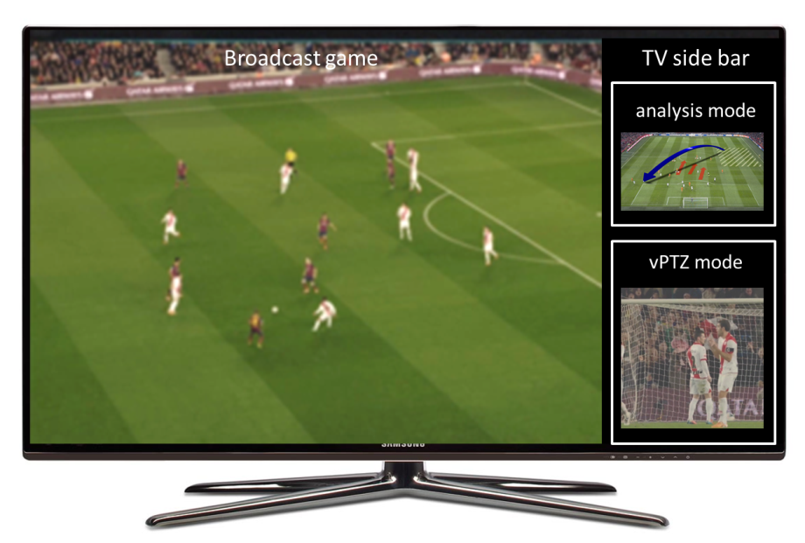

Figure 13: an interactive TV screen application.

The second NL demo consists of an interactive application, running on a set-top box, provisioning for limited interaction based on a side bar menu. Features include multiple custom video channels, such as different camera angles, player tracking cameras, or an analysis-mode view.

***3/ Interactive smartphone application***

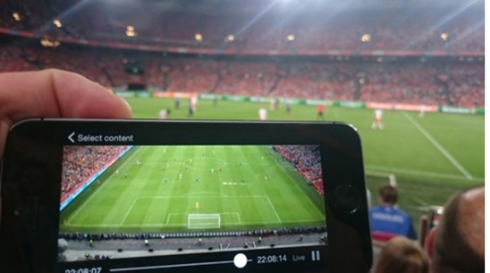

Figure 14: an interactive smartphone application.

The third NL demo consists of an interactive application, running on a smartphone, offering in-stadium interaction and content, such as highlight videos, interactive replay videos and an analysis mode. In addition, voting/betting features are implemented.

* 1. Demonstration at remote locations in Korea and Turkey

**

Figure 15: an interactive smartphone application.

In Korea, a wide screen with multiple TVs or panels will show the immersive video at a public place. The public viewing system will receive the multiple video streams and manipulate for spatial and temporal synchronization.

* 1. Online Debate Application

As a part of the overall MOS2S demonstrator, the Turkish demonstrator will focus on developing “Online Debate” application, based on image equalization and infrastructure components of online debating. This application enables a group of people to meet up online by using their mobile phones or tablets at anywhere for talking about whether the happened position was correctly evaluated or not. This work requires performing a study on selection, design, development and application of the most appropriate streaming, transcoding and transrating methods in transferring multi-channel video streams with accompanying text content to both mobile and we connected devices which have different processing power and different internet band widths.

* Furthermore, “Online Debate” might evolve to a supporting structure for Crowd Journalism applications.
* Online Debate has some similar features with Kiswe, such as;
  + Easy access; user can easily watch a live debate and also the web site,
  + Multi-stream event experience
  + Variety of events; an audience can select an event depending on her/his concerns.
  + Live video; all debaters can watch each other at same time
  + Live chat; debaters can send text message to moderator of debate
  + End users can create a debate whenever they want
  + Social media contribution; audience can express himself/herself and also can support debater who has similar ideas,
  + Access both live and previously completed debates, and watch their videos on the website
* Online Debate Web site has some similar features with [Balloter](https://www.ballotter.com/) and [QualOut](https://www.qallout.com/) websites,
  + Access both live and previously completed debates, and watch their videos on the website

1. Concluding Remarks

This Deliverable D1.1.2 provides use case descriptions and demonstrator definitions for the 2nd year milestone. The document outline use case descriptions and requirements with a focus on public and mobile screen usages at the venue and the remote locations and clarifies the contributions from the participating countries. Compelling fan experience concepts are described around a single live event. We have selected a soccer event on September as a premier event to showcase initial MOS2S system and application concepts; in the period towards the demonstrator (Q3 2018), the MOS2S consortium is dependent on the Future of the Match and IBC 2018.